**Guidelines for manuscript preparation**

**A. B. Author**1 and **C. D. Coauthor**2

1 Name of Institution, City, Country, e-mail

2 Name of Institution, City, Country

One-page synopses of all invited, oral and poster presentations for the VIII International Conference «Frontiers of Nonlinear Physics» will be published and distributed among participants during the Conference. Correctly formatted, ready-to-print manuscripts should be submitted by all accepted authors. Submissions should be made by the due date through the Conference website [www.fnp2024.physconf.org](http://www.fnp2024.physconf.org) (registration & abstract submission form). Using this method of submission ensures that your summary will be immediately accessible to the Conference Program Committee, who may require manuscript revision before approving a publication and reserve the right to reject any manuscript that does not meet the requirements.

Manuscripts in English should be submitted before or on **20 May, 2024.** This dateshould be strictly observed and late manuscripts may not be published.

Manuscripts should be prepared in the MS Word format. Please note that papers will be printed in black and white.

The text of the manuscript prepared for direct reproduction should fit in the 16 × 25 cm frame (top margin – 2 cm, bottom margin – 2.5 cm, left margin – 2 cm, right margin – 2 cm) arranged in two columns with a gap of 0,6 cm, as shown in this template.

The **total length** of the paper should not exceed 1 page. Please avoid too much empty space at the page.

The **title** of the paper should be centered and typed in lower-case Times New Roman bold, 14 pt, space after   
12 pt. The names ofthe **authors** should be centered and typed in Times New Roman bold, 12 pt, space after 6 pt. The name of the presenting author should be underlined. **Affiliations** should be centered and typed in Times New Roman, 9 pt, space after 12 pt.

**Headings**

For headings, use Times New Roman, 10 pt, bold, with first-line indent 6 mm, space before 6 pt, space after 6 pt.

The **body of the text** should be in Times New Roman, 10 pt, justified, single-spaced, with first-line indent 6 mm, hyphenated.

**Figures** should preferably fit the width of a column or, for larger figures, the width of the page, margin to margin. Use 9 pt for figure captions and center the caption relative to the figure or the margins.

All variables in **formulas** should be italicized, greek letters should NOT be italicized (for example,   
*E* = *mc*2, div **E** = 4 π*q*). Displayed **equations** should be centered and enumerated on the right:

. (1)

Please, avoid extensive use of formulas and figures.

**Subheadings**

Please avoid subheadings unless absolutely necessary. When required, use Times New Roman, 10 pt, bold, with first-line indent 6 mm, space before 6 pt, space after 6 pt.

**Acknowledgements.** If the research was supported by some foundation, please do not forget to state the fact.

NB: The authors are expected to submit original material. The extended summaries should contain enough detail to clearly convey the approach and the results of the research. It is understood that the authors have obtained all permissions and clearances, if necessary.

References

1. A. One, B. Two, and C. Three, *Phys. Rev*., 1972, **8**(3), 555-566.
2. D. Four and E. Five, *Proc. 6th Intern. Conf. Nonlinear Physics: ICNW VI*, F. Six (Ed.), Moscow, 1999, 555-560.
3. J. Seven, *Nonlinear Physics*, Wiley, New Work, 1999,   
   p. 234.

example

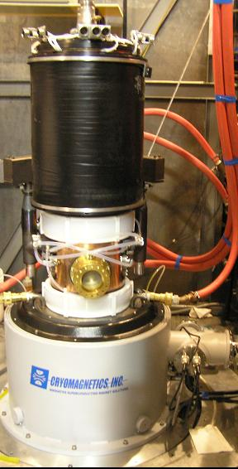

**Fig. 1.** Photograph of the 95 GHz oscillator installed   
in the test stand at CPI

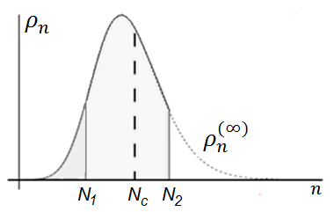

**Fig. 2.** The probability distribution of the noncondensate occupation for a small number of atoms *N=N1*< *Nс* (noncondensed phase) and a large number of atoms *N=N2>Nс* (BEC phase). The dotted line depicts the unconstrained probability distribution of the noncondensate occupation